|  |
| --- |
| **A**  **PROJECT REPORT ON** |
|  |
|  |
| **“ONLINE POLICY MANAGEMENT SYSTEM”** |
|  |
|  |
| SUBMITTED IN  PARTIAL FULFILLMENT OF  **DIPLOMA IN ADVANCED COMPUTING (PG-DAC)** |
|  |
|  |
|  |
|  |
|  |
|  |
|  |
| **BY**  **Akash Wadhawane, Shamali Mane** |
|  |
|  |
| **UNDER THE GUIDENCE OF**  **Girish Barhate** |
|  |
|  |
|  |
| **AT**  **SUNBEAM INSTITUTE OF INFORMATION TECHNOLOGY,**  **PUNE** |

|  |  |
| --- | --- |
|  | |
| **SUNBEAM INSTITUTE OF INFORMATION TECHNOLOGY,**  **PUNE.** | |
|  | |
|  | |
|  | |
|  | |
| **CERTIFICATE** | |
|  | |
| This is to certify that the project | |
|  | |
| **“ONLINE POLICY MANAGEMENT SYSTEM”** | |
|  | |
| Has been submitted by | |
|  | |
| **Akash Wadhawane** | |
|  | |
|  | |
| In partial fulfillment of the requirement for the Course of **PG Diploma in Advanced Computing (PG-DAC AUG2019)** as prescribed by The **CDAC** ACTS, PUNE. | |
|  | |
|  | |
| Place: | Date: |
|  | |
|  | |
|  | |
|  | |
|  | |
| **<Project Guide Name>** | **<Alumni Mentor Name>** |
| **Project Guide** | **Alumni Mentor** |

**ACKNOWLEDGMENT**

A project usually falls short of its expectation unless aided and guided by the right persons at the right time. We avail this opportunity to express our deep sense of gratitude towards Mr. Sarang Patil (Director, SIIT Karad), Mr. Prashant Lad (Course Coordinator,SIIT, Karad) and Mr. Girish Barhate (Our Project Guide and Faculty Member,SIIT Karad).

We are deeply indebted and grateful to them for their guidance, encouragement and deep concern for our project. Without their critical evaluation and suggestions at every stage of the project, this project could never have reached its present form. Last but not the least we thank the entire faculty, especially all the staff members of Sunbeam Institute of Information Technology, Karad for their support.

TEAM SUNBEAM

DAC August 2019 Batch,

SIIT Karad

**ABSTRACT**

The online policy management system project manages the activities related to insurance of people and there information and data to the insurance company. The insurance can be for the any company,any human being or any other product such as vehicle,mobile,etc.

Adding to it this system contains policy details that can be accessible by customer and handled by the administrator. The user can add new policy and paid premium by calculating it on premium calculator. And the admin can view all the details of the user and manage it by using admin dashboard. The user can track on there policy by using claim tracker.

Furthermore,the insurance holder can view details of there policies and manage there profile whereas administrator or insurance company can manage or view all details of customers there policies and can track there valuable customers. Also they can view the customer’s inactive policies. With this information they can reach out to the customer.

**INDEX**

|  |  |  |
| --- | --- | --- |
|  | **INTRODUCTION** | 1 |
|  | 1.1 Introduction | 2 |
|  | **Product Overview and Summary** |  |
|  | 2.1 Purpose |  |
|  | 2.2 Scope |  |
|  | 2.3 User Classes and Characteristics |  |
|  | 2.4 Design and Implementation Constraints |  |
|  | **REQUIREMENTS** |  |
|  | 3.1 Functional Requirements |  |
|  | 3.1.1 Use case for Administrator. |  |
|  | 3.1.2 Use case for Customer. |  |
|  | 3.2 Non - Functional Requirements |  |
|  | 3.2.1 Usability Requirement |  |
|  | 3.2.2 Performance Requirement |  |
|  | 3.2.3 Reliability Requirement |  |
|  | 3.2.4 Portability Requirement |  |
|  | 3.2.5 Security Techniques |  |
|  | **PROJECT DESIGN** |  |
|  | 4.1 Data Model |  |
|  | 4.1.1 Database Design |  |
|  | 4.2 Process Model |  |
|  | 4.2.1 Functional Decomposition Diagram |  |
|  | 4.2.2 Data Flow Diagram (DFD) |  |
|  | **TEST REPORT** |  |
|  | **PROJECT RELATED STATISTICS** |  |
|  | **CONCLUSION** |  |

**LIST OF TABLES**

|  |  |  |
| --- | --- | --- |
| **Section** | **Table Title** | **Page** |
|  |  |  |
|  |  |  |
|  |  |  |
|  |  |  |
|  |  |  |
|  |  |  |

**LIST OF FIGURES**

|  |  |  |
| --- | --- | --- |
| **Section** | **Figure Title** | **Page** |
|  |  |  |
|  |  |  |
|  |  |  |
|  |  |  |
|  |  |  |
|  |  |  |
|  |  |  |
|  |  |  |
|  |  |  |
|  |  |  |
|  |  |  |
|  |  |  |

**Functional Requirements:**

**Description :**

Our project Online Insurance Policy Management System has two modules. In Client module he can sign in, choose a policy, view its description, calculate payable premium using premium calculator and buy online. In admin module he can add new policy, make changes in existing policy and manage claims.

Online Policy Management System contains two modules. As follows :

A.User

B.Admin

A] **User:**

1)**Registration:**

System will take inputs from user like Name, Nominee, Nominee Relation, DOB,Gender,Address,City,State,Country,Pin code,Mobile,Email,PAN Number, User Profile Image, Adhar Number,Password. It is necessary to enter this details for registration,then it goes to login page to login into system.

2)**Log In**:

The System will take User ID/Email ID and Password for log in into system. The valid User ID logged in into system if not then it show wrong details entered. If user is not registered then by clicking log in button it goes to registration page.

3)**User Dashboard:**

This page contains all details of policies of user purchased and all functionalities and services provided by system.

**Details:**

* Buy new policy
* policy details
* claim tracker
* premium date
* history of paid premium

4)**Buy New Policy:**

This page shows all policies/plans which user can buy,check details,premium calculator.

5)**Individual Plan Details:**

This page includes all details and benefits of each plan system offers. By clicking,Buy button it goes to calculator page.

6)**Premium Calculator**:

The Premium Calculator page can calculate premium amount and total amount by getting values of product ID,payment frequency. After that user can buy that policy.

7)**Edit Profile:**

The User can edit Mobile Number,Email ID, User Profile Image user can also change password.

8)**Premium Pay**:

The User can pay due premium amount on premium pay page.By clicking Pay button it goes to user dashboard.

9)**Policy Details:**

Policy Details page shows all the details of policies user purchased.

**Details:**

* Policy Number
* Nominee
* Address
* Start Date
* Maturity Date
* Total paid Premium
* Total invested amount
* Total matured Amount

10)**History Of Paid Premium:**

The History Of Paid Premium page displays all the history of paid premium with following details:

* Policy Number
* Date
* Premium Amount
* Total Premium count

11)**Claim Tracker:**

The Claim Tracker page shows status of all claim applications. It will take input user like claim application number,DOB. It displays associated details.

**B] ADMIN :**

1)**Admin Log in:**

The system will take Admin ID and Password for log in into system. The valid Admin ID logged in into system if not then it show wrong details entered. And goes to admin dashboard.

2)**Admin Dashboard:**

This page contains all functionalities and services provided by system for admin. As follows :-

* Add new policy
* Customer policy details
* Make changes in existing policy
* Manage claims
* Inactive policies

3)**Add New Policy**:

In Add New Policy page,admin can add new plans and policies with details like benefits,years,amount of insurance. By clicking save button it goes to admin dashboard.

4)**Make Changes in Existing Policies:**

In Make changes in existing policies page,admin can edit existing policy with new details and benefits. By clicking save button it goes to admin dashboard.

5)**Manage Claims:**

In Manage claims,admin can add claim,edit claims status by providing following details:

Policy number

Claim application number

Customer/user Id

Claim status

By clicking save button it goes to admin dashboard.

6)**Inactive Policy:**

In Inactive policy, admin can check all inactive policies and details of users who have inactive policies.

7)**Customer and Policy Details:**

The Customer and Policy Details page contains details of customer and there associated policy details as follows:

* Name
* Nominee
* Nominee Relation
* DOB
* Gender
* Address
* City
* State
* Country
* Pin code
* Mobile
* Email
* PAN Number
* Adhar Number
* Policy Number
* Start Date
* Maturity Date
* Total paid Premium
* Total invested amount
* Total matured Amount

**Use Case Diagrams:**

**Use case for Administrator:**

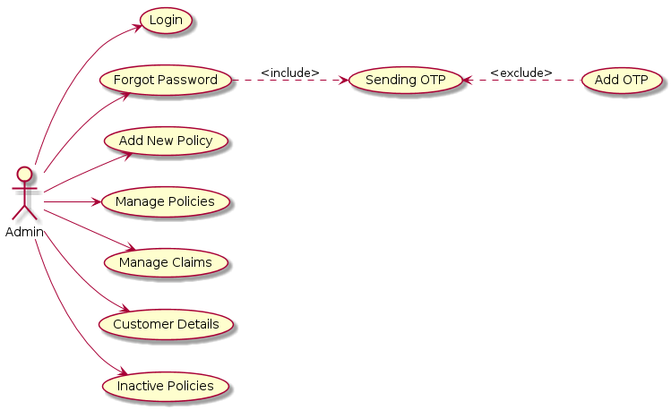

**Use case for User:**

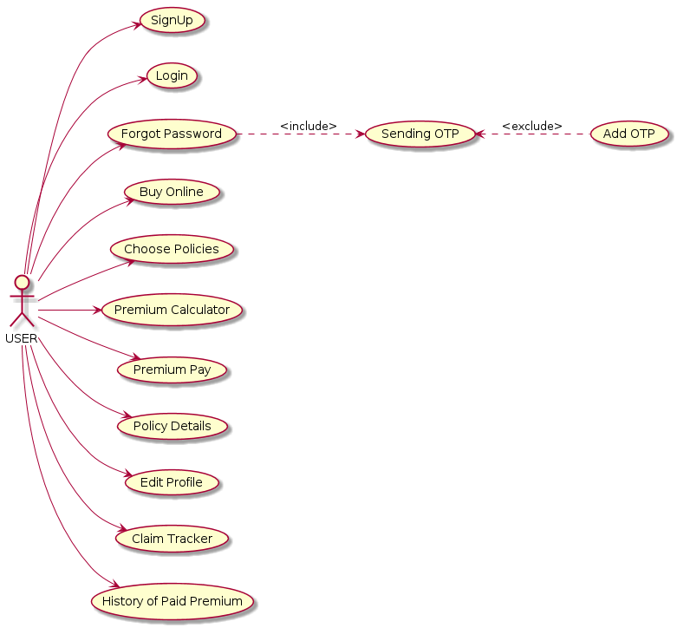

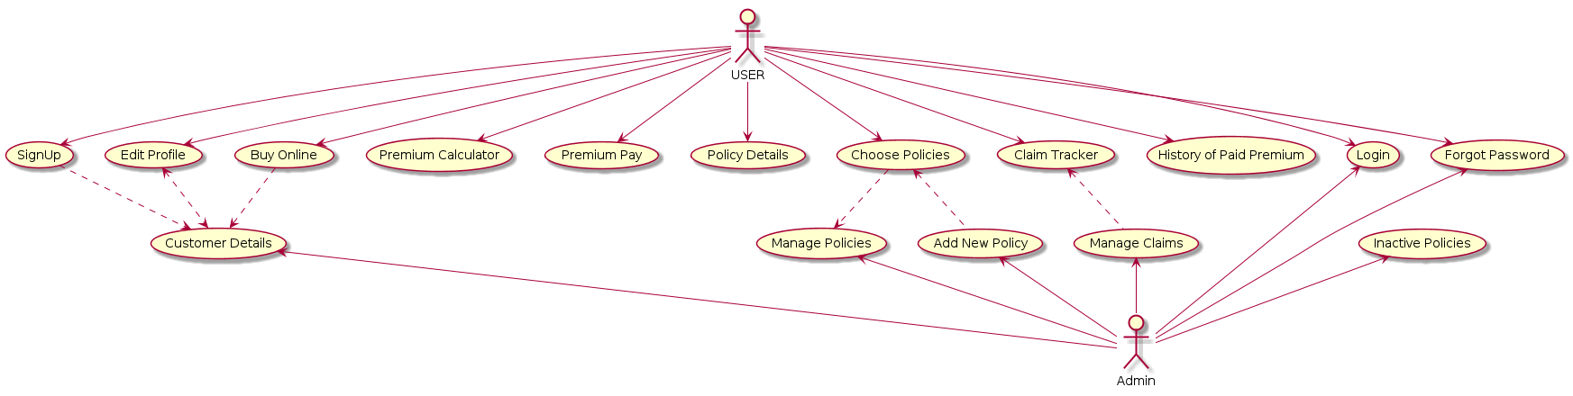

**Database Design :**

Add new policy:



Claim Details:



Customer Policy Details:



Customer Details:



History Paid Premium:



OTP Details:



Pass Details:



Premium Schedule:



Role details:



User Details:



**UI Design:**

**Registration:**

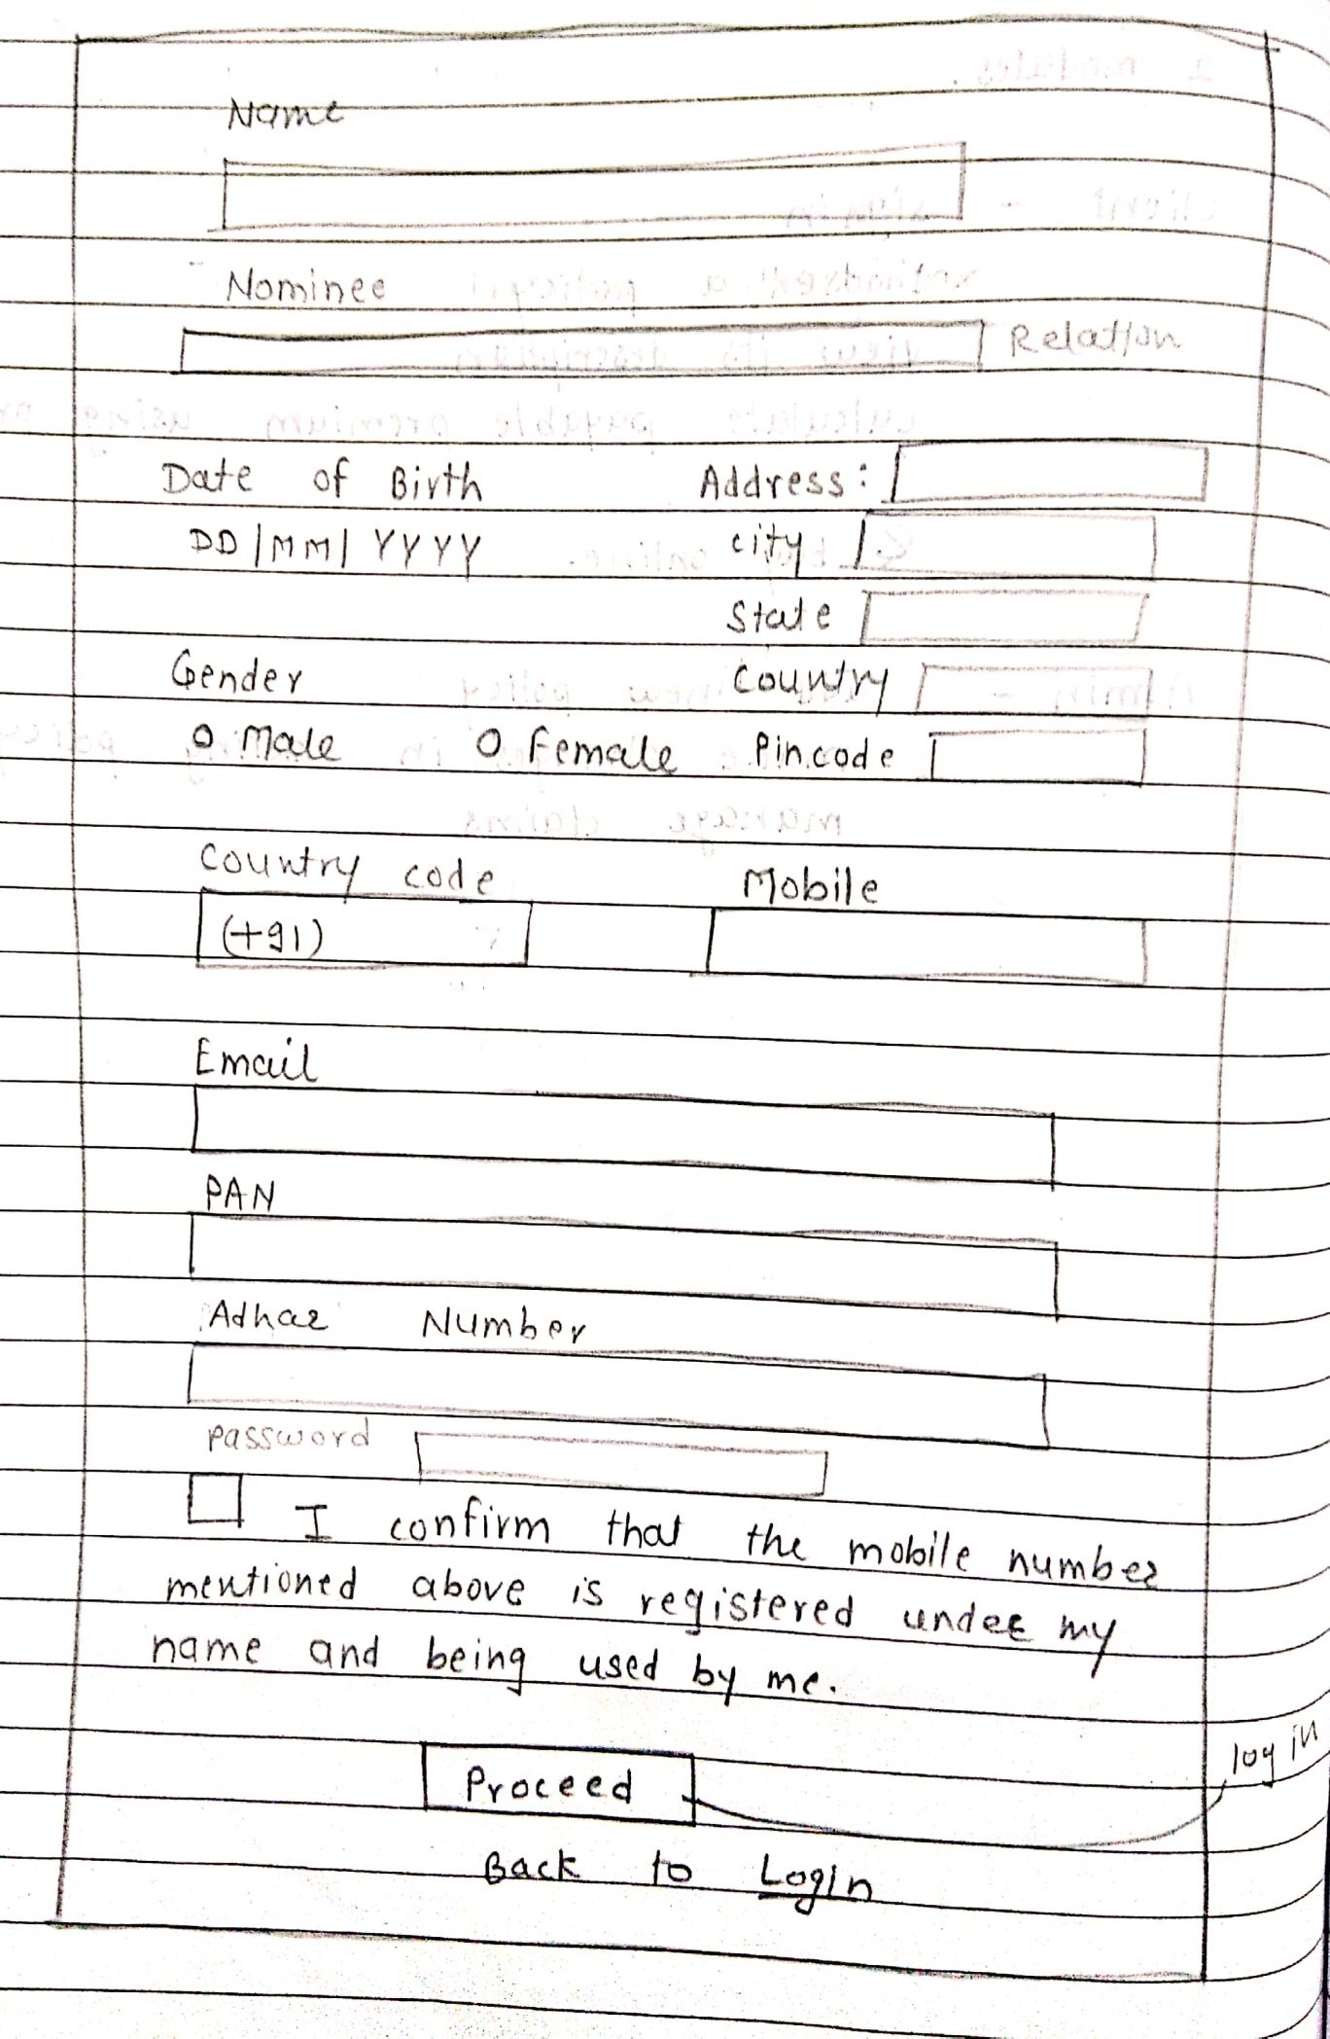

**Log in:**

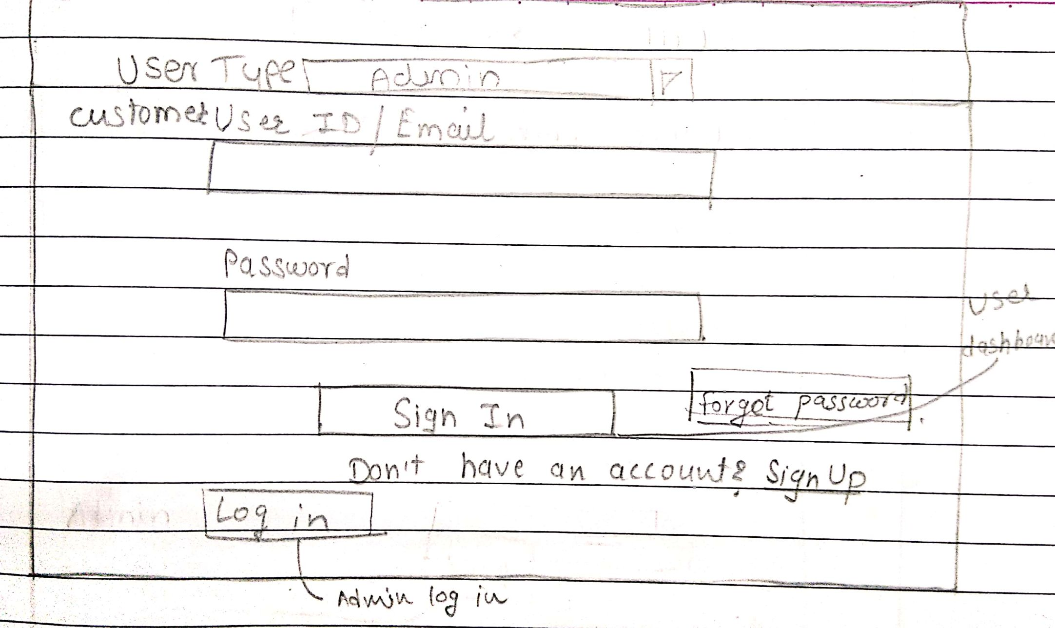

**Buy new policy:**

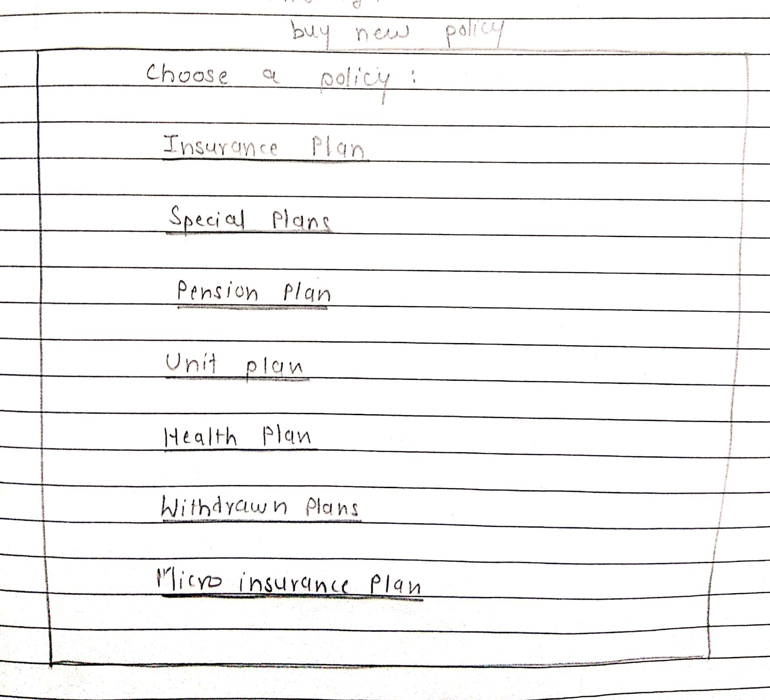

**Policy Information:**

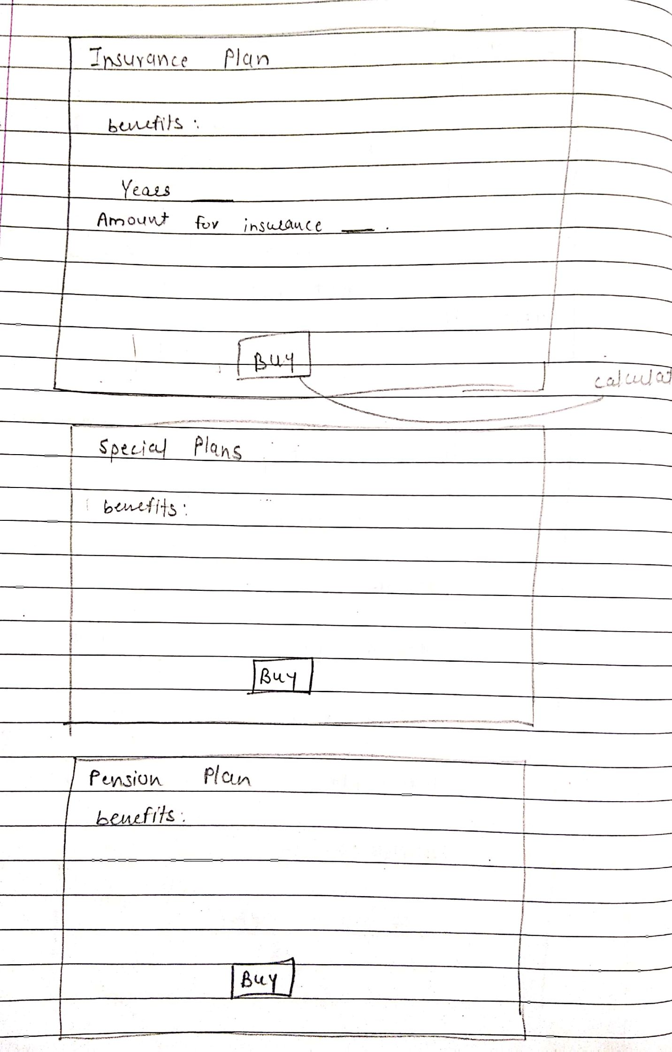

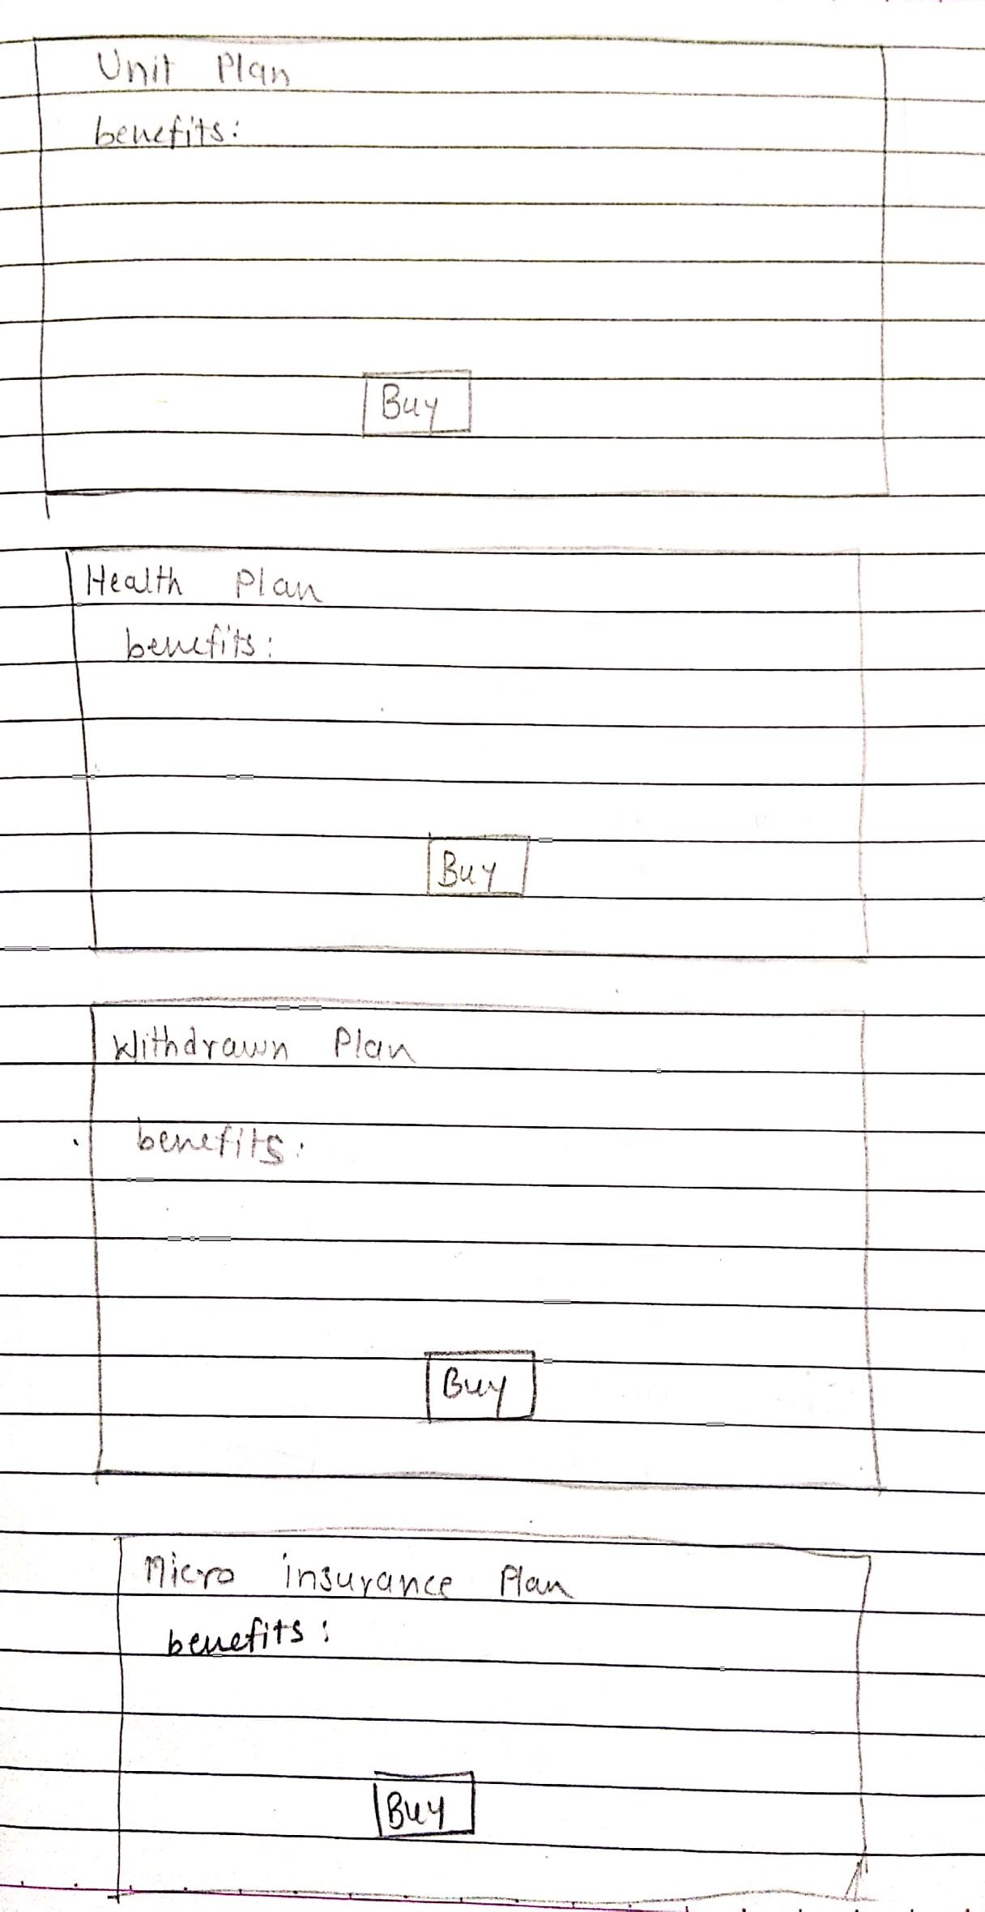

**Calculator:**

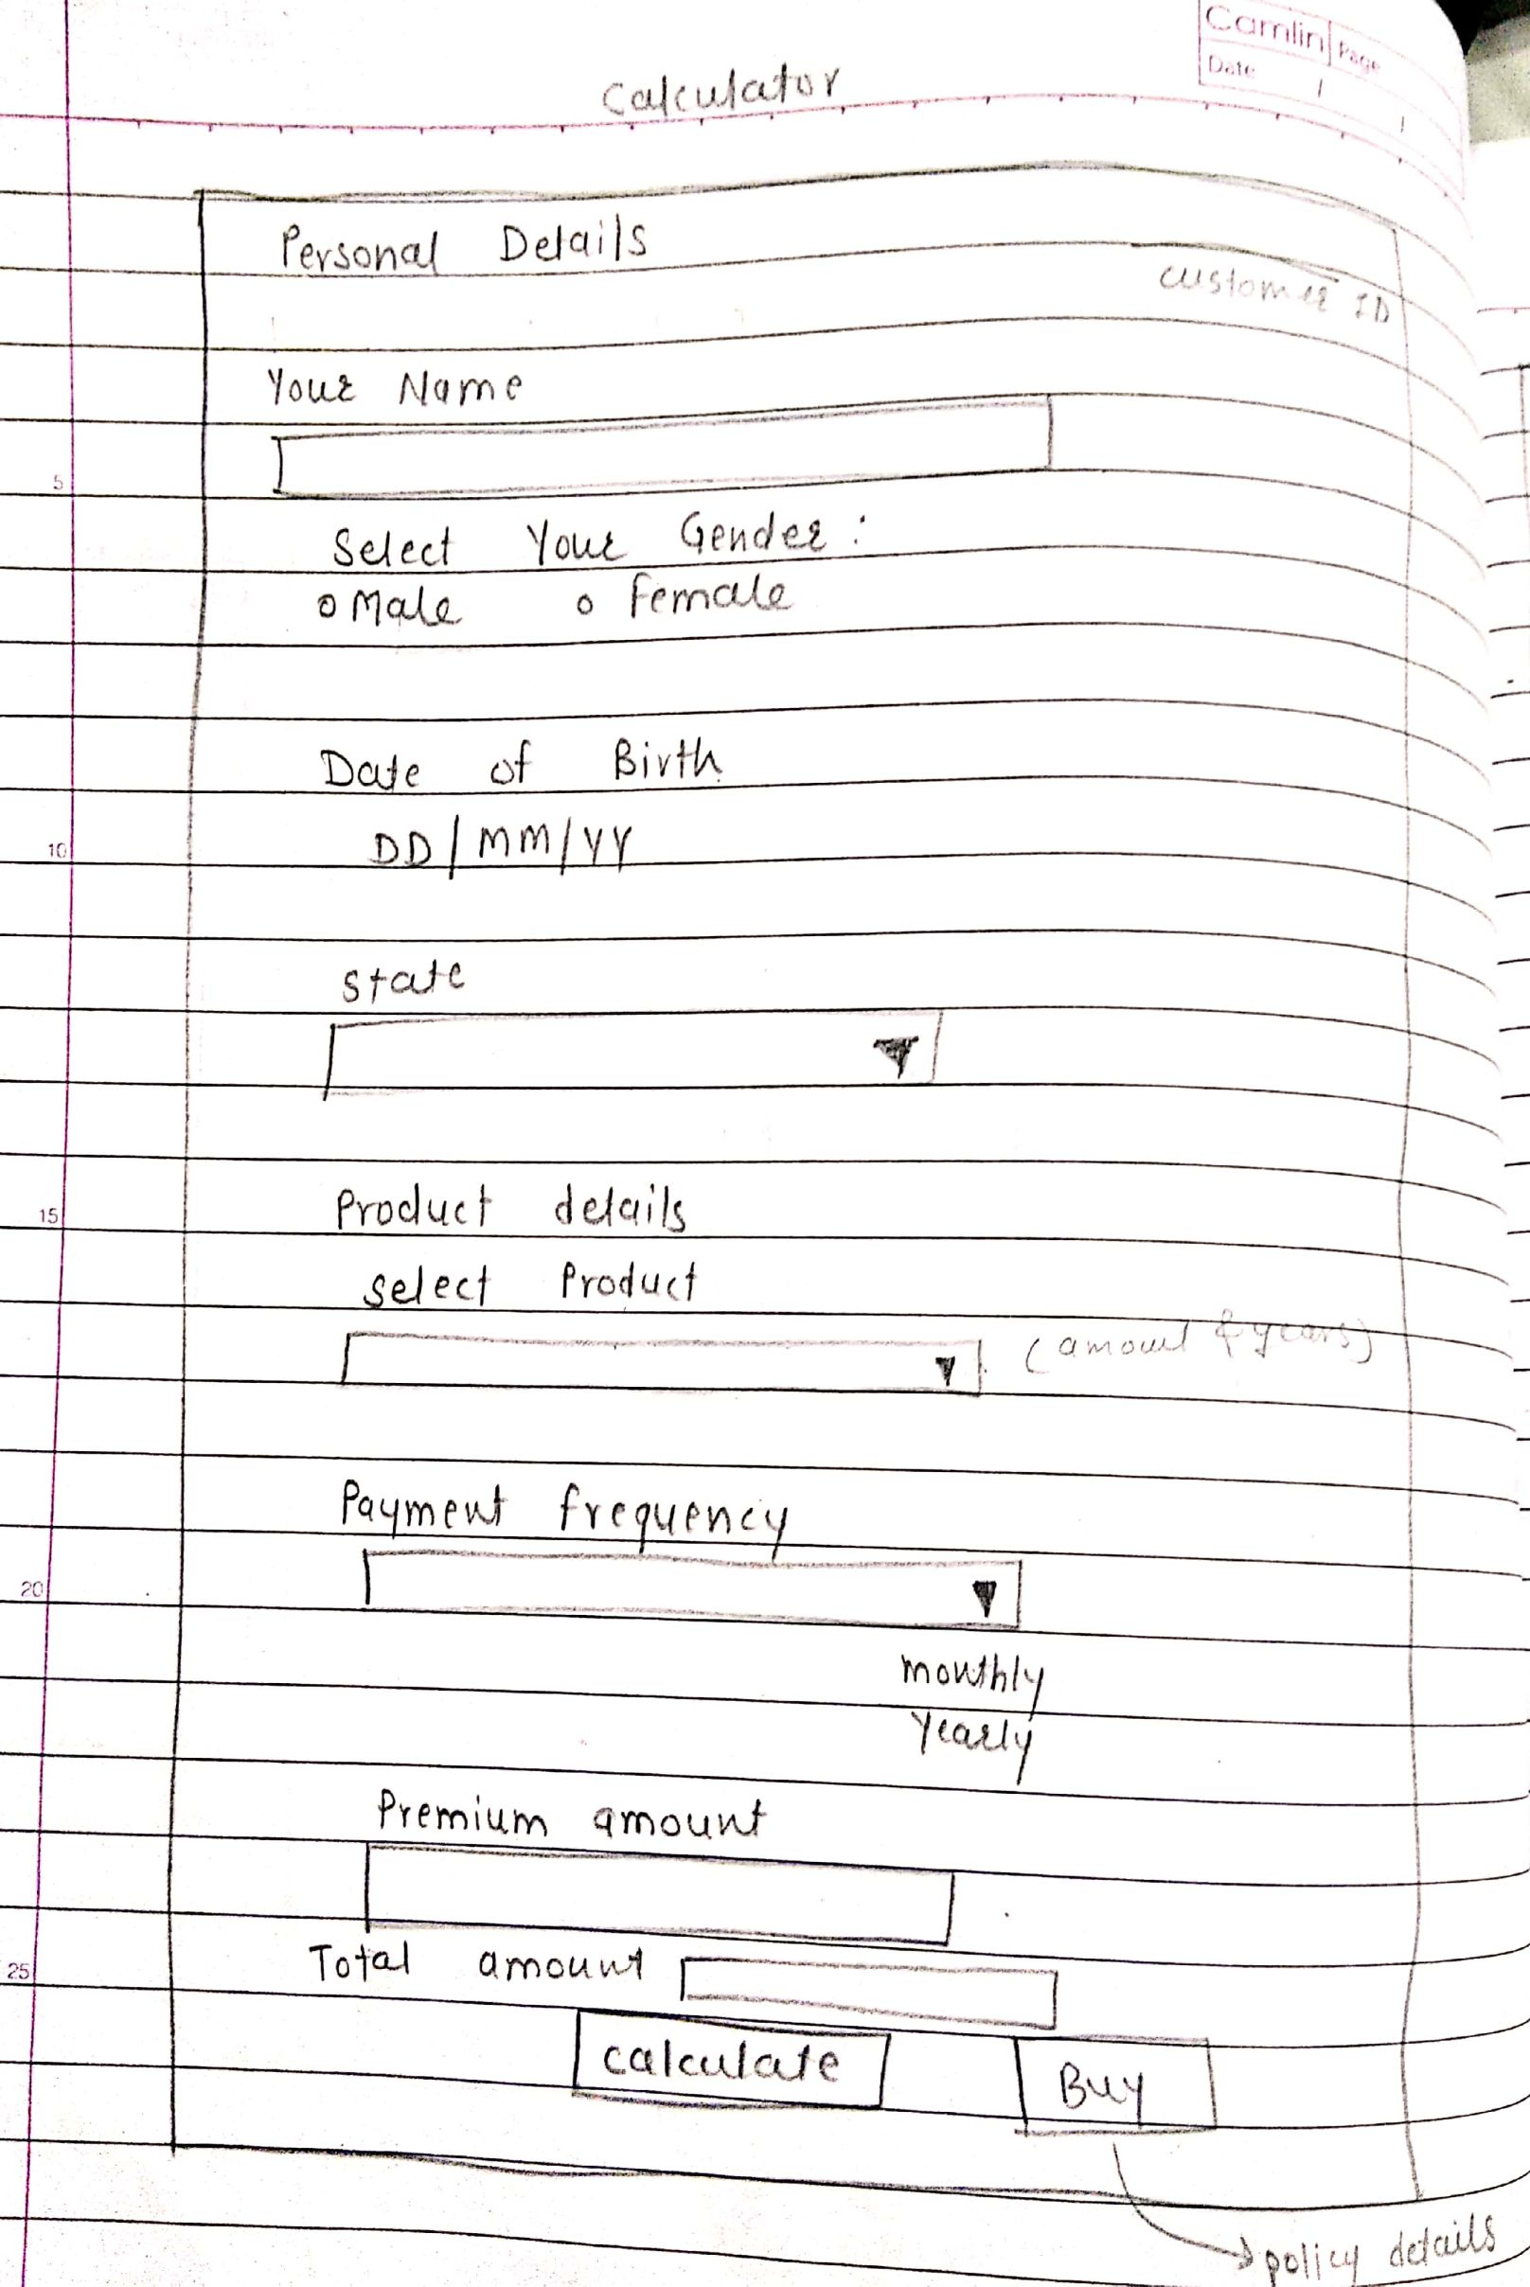

**User Dashboard:**

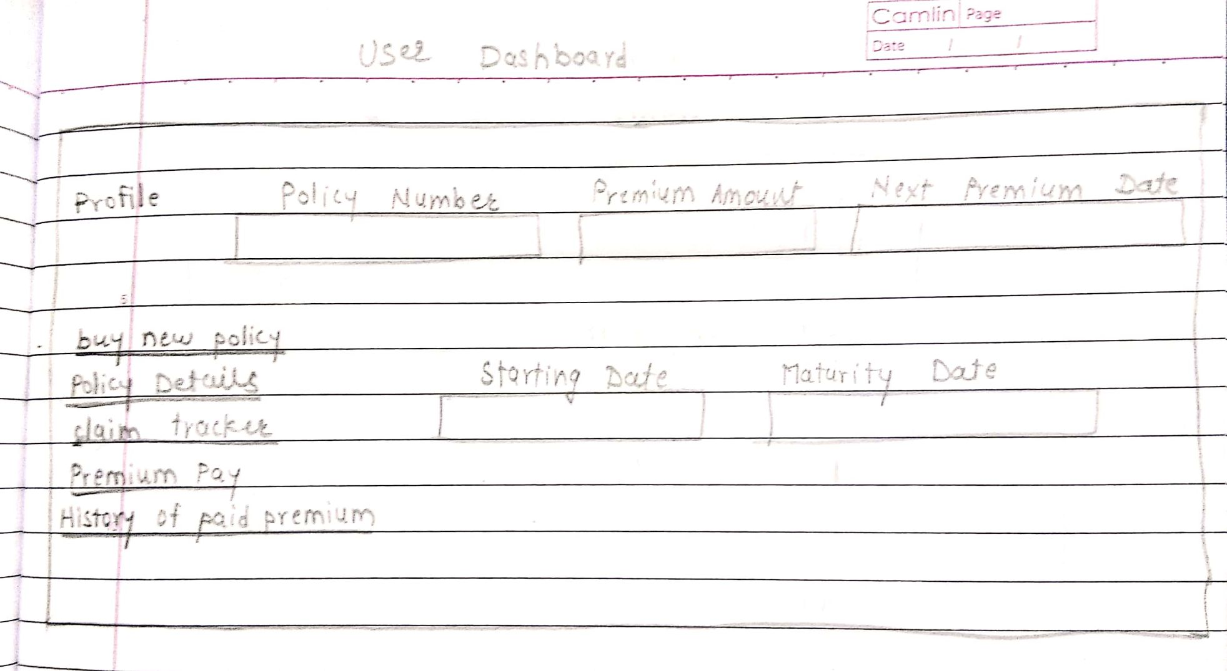**Edit Profile:**

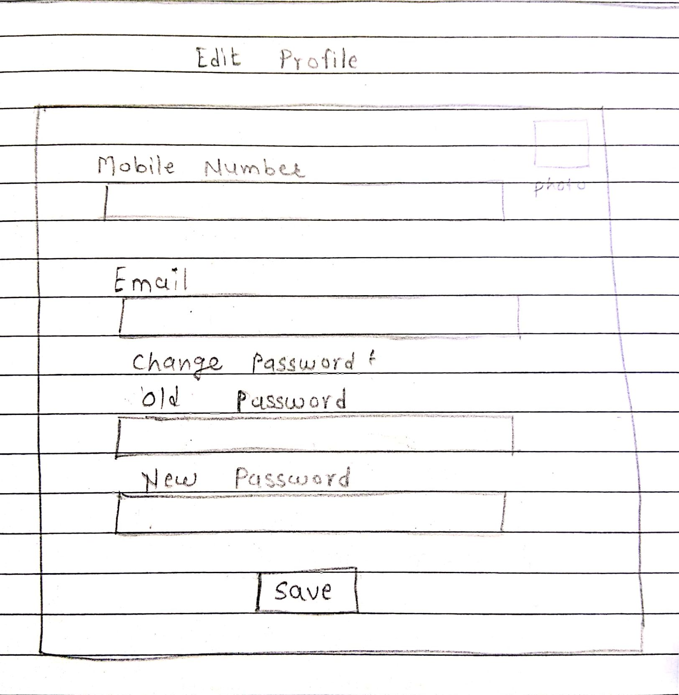

**Claim Tracker:**

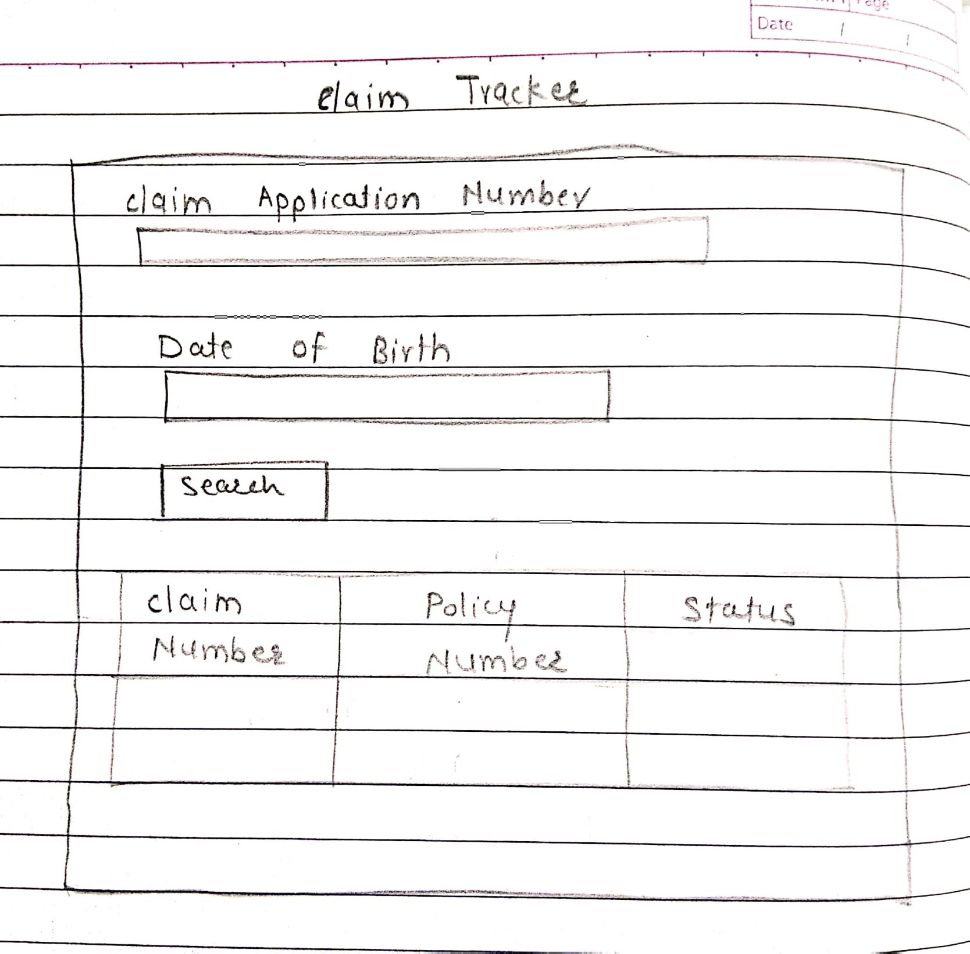

**Premium Pay:**

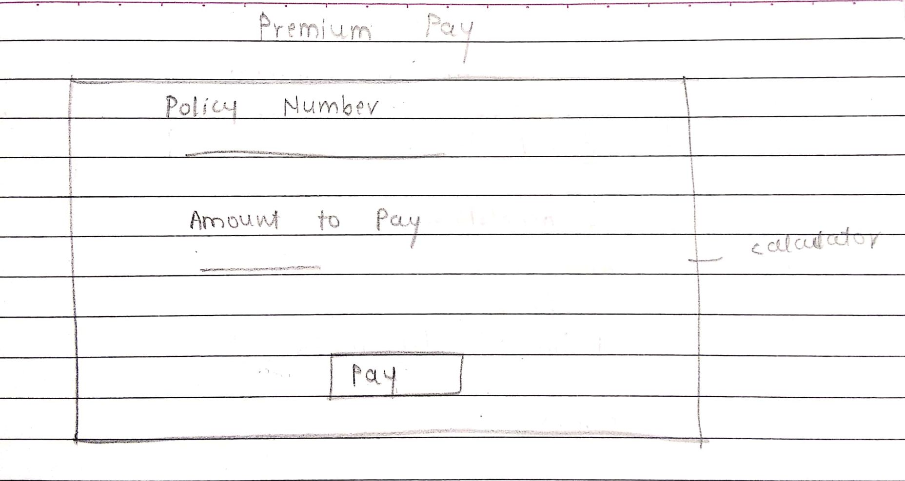

**History Of paid premium:**

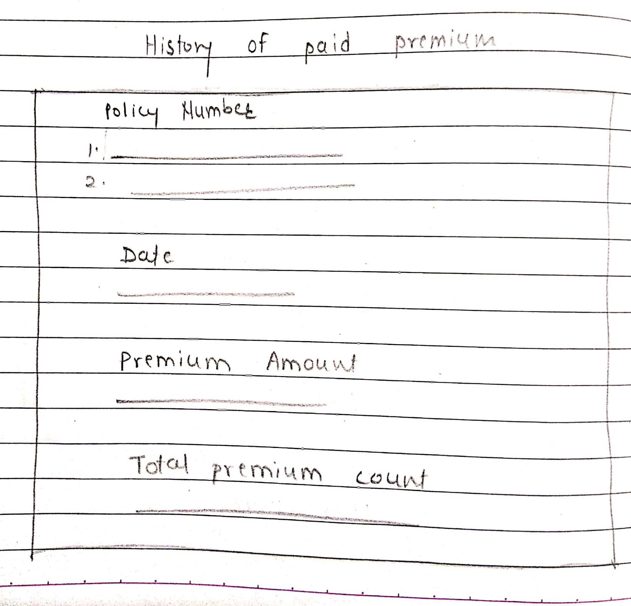

**Policy Details:**

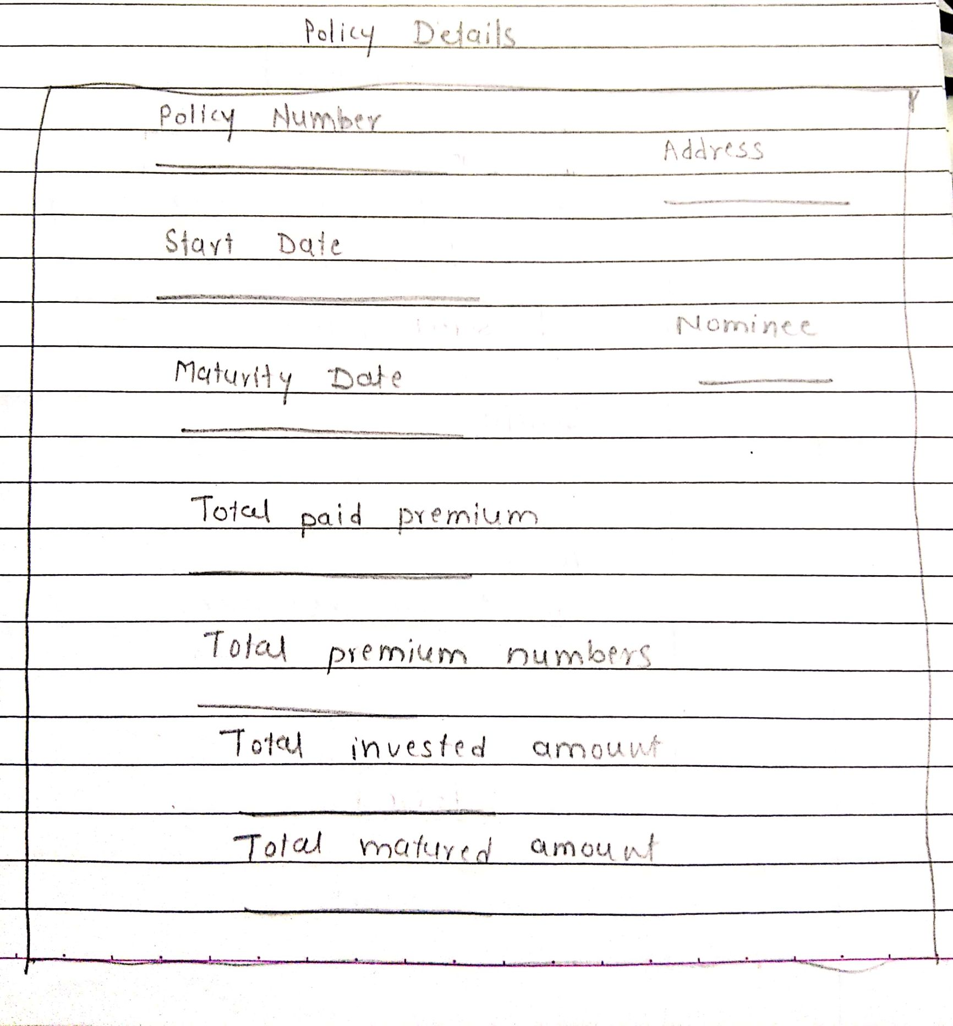

**Admin:**

**Add new policy:**

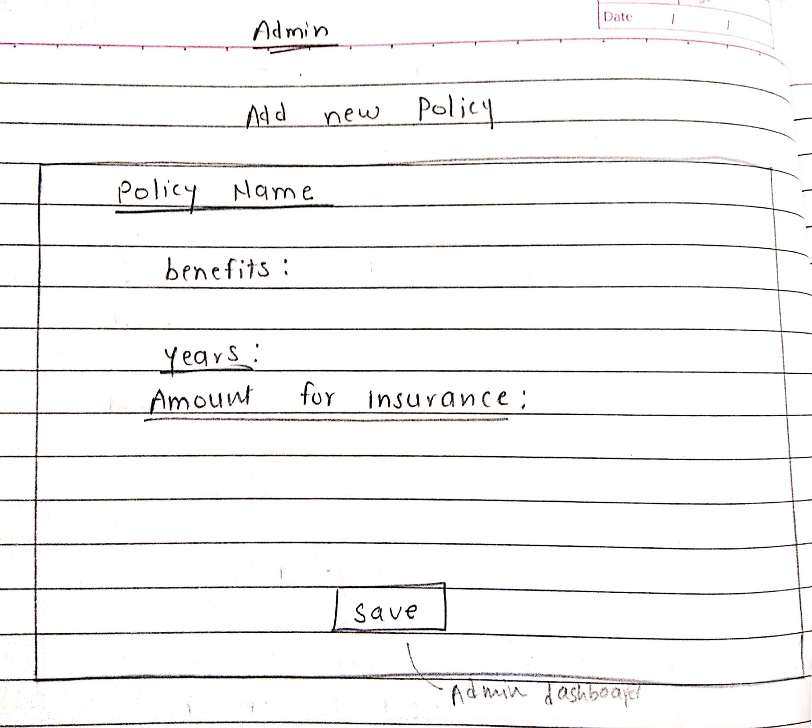

**Make changes in existing policy:**

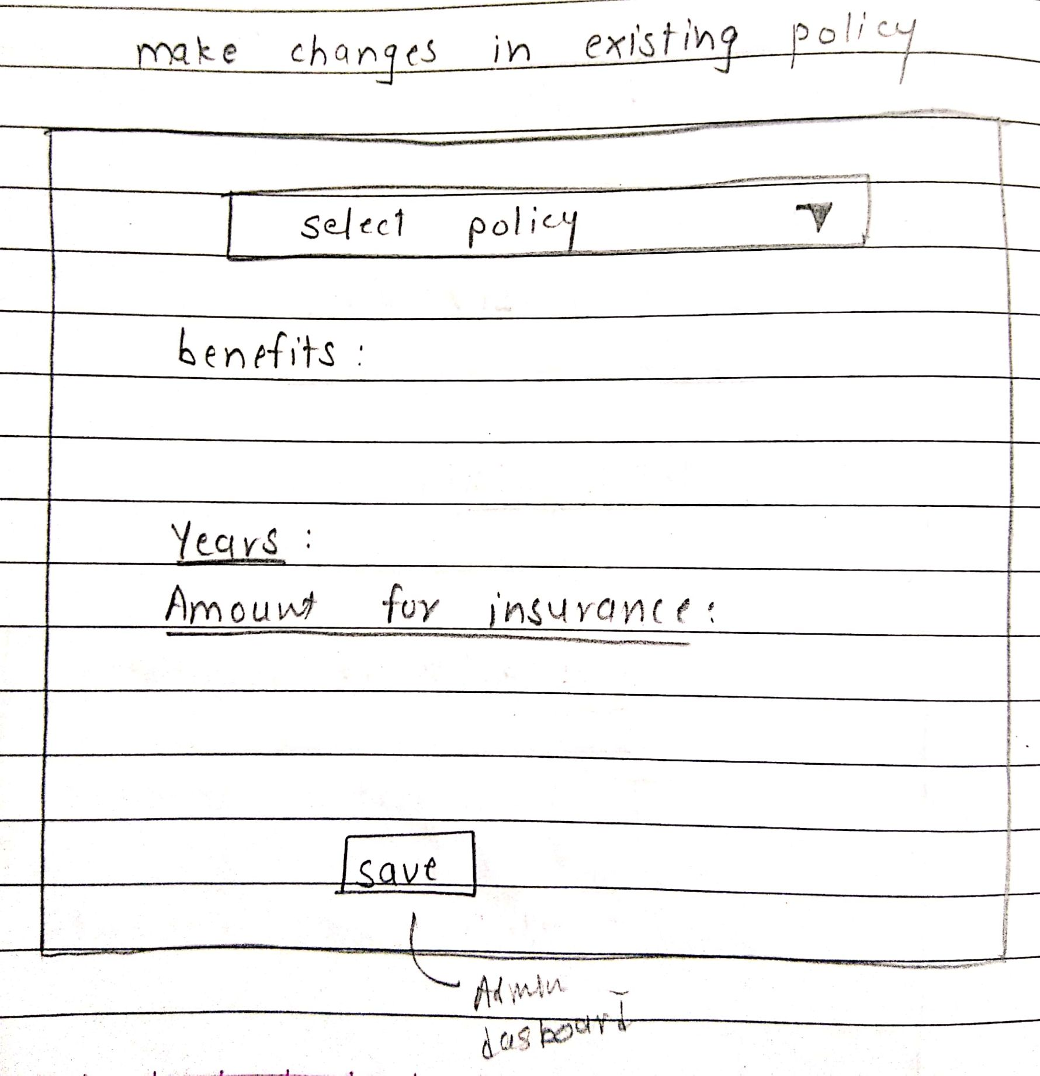

**Manage Claims:**

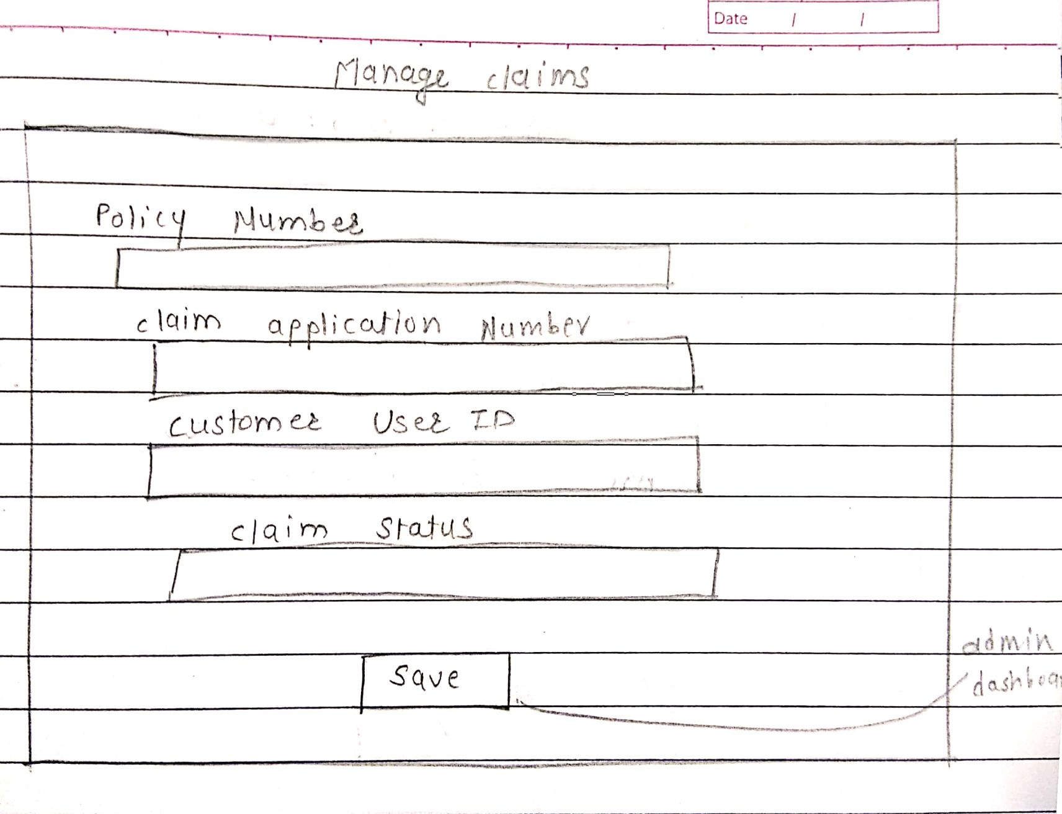**Inactive Policy:**

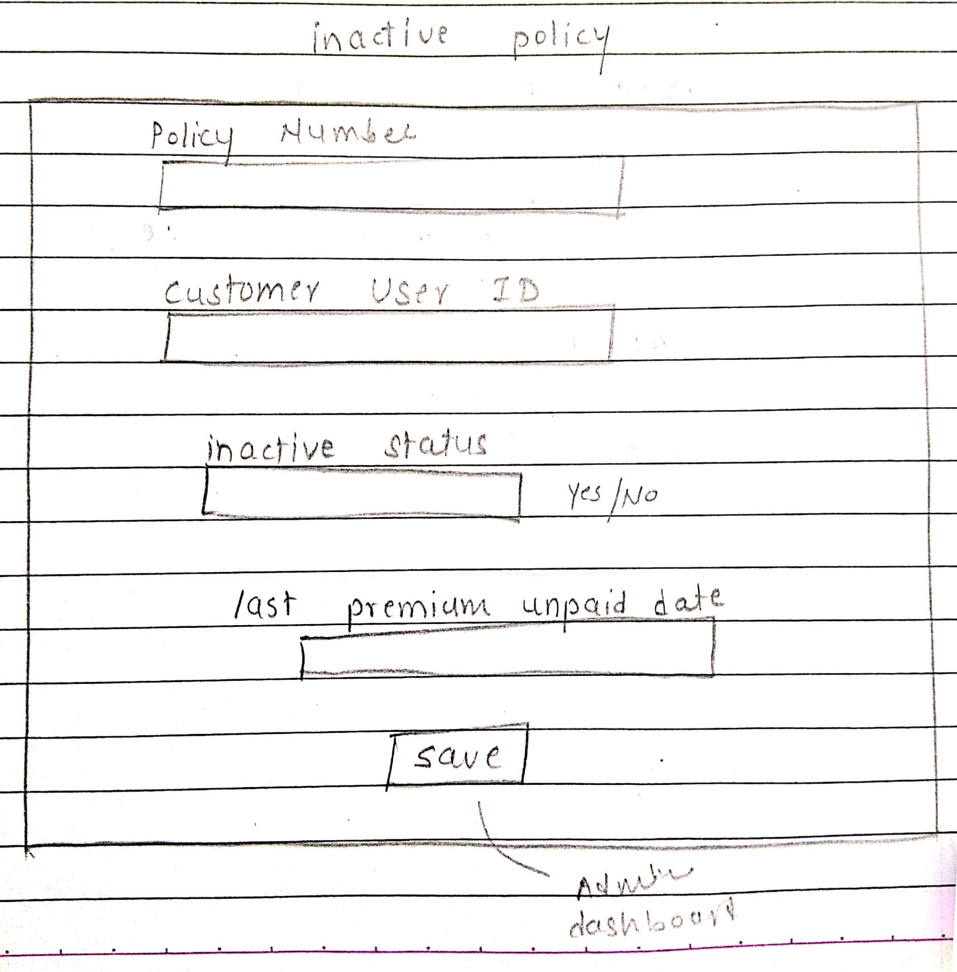

**Customer and policy details:**

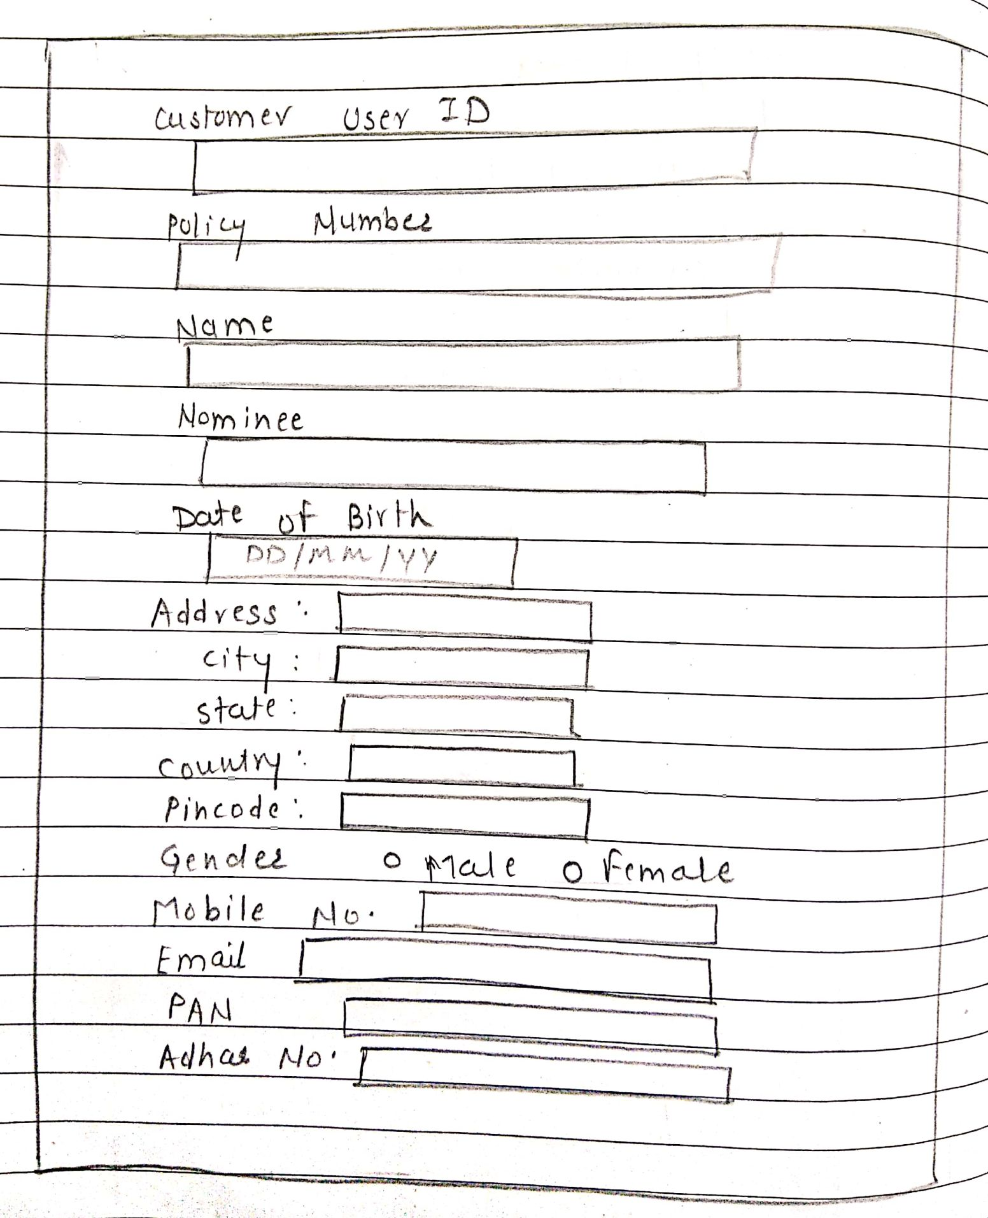

**Admin Dashboard:**

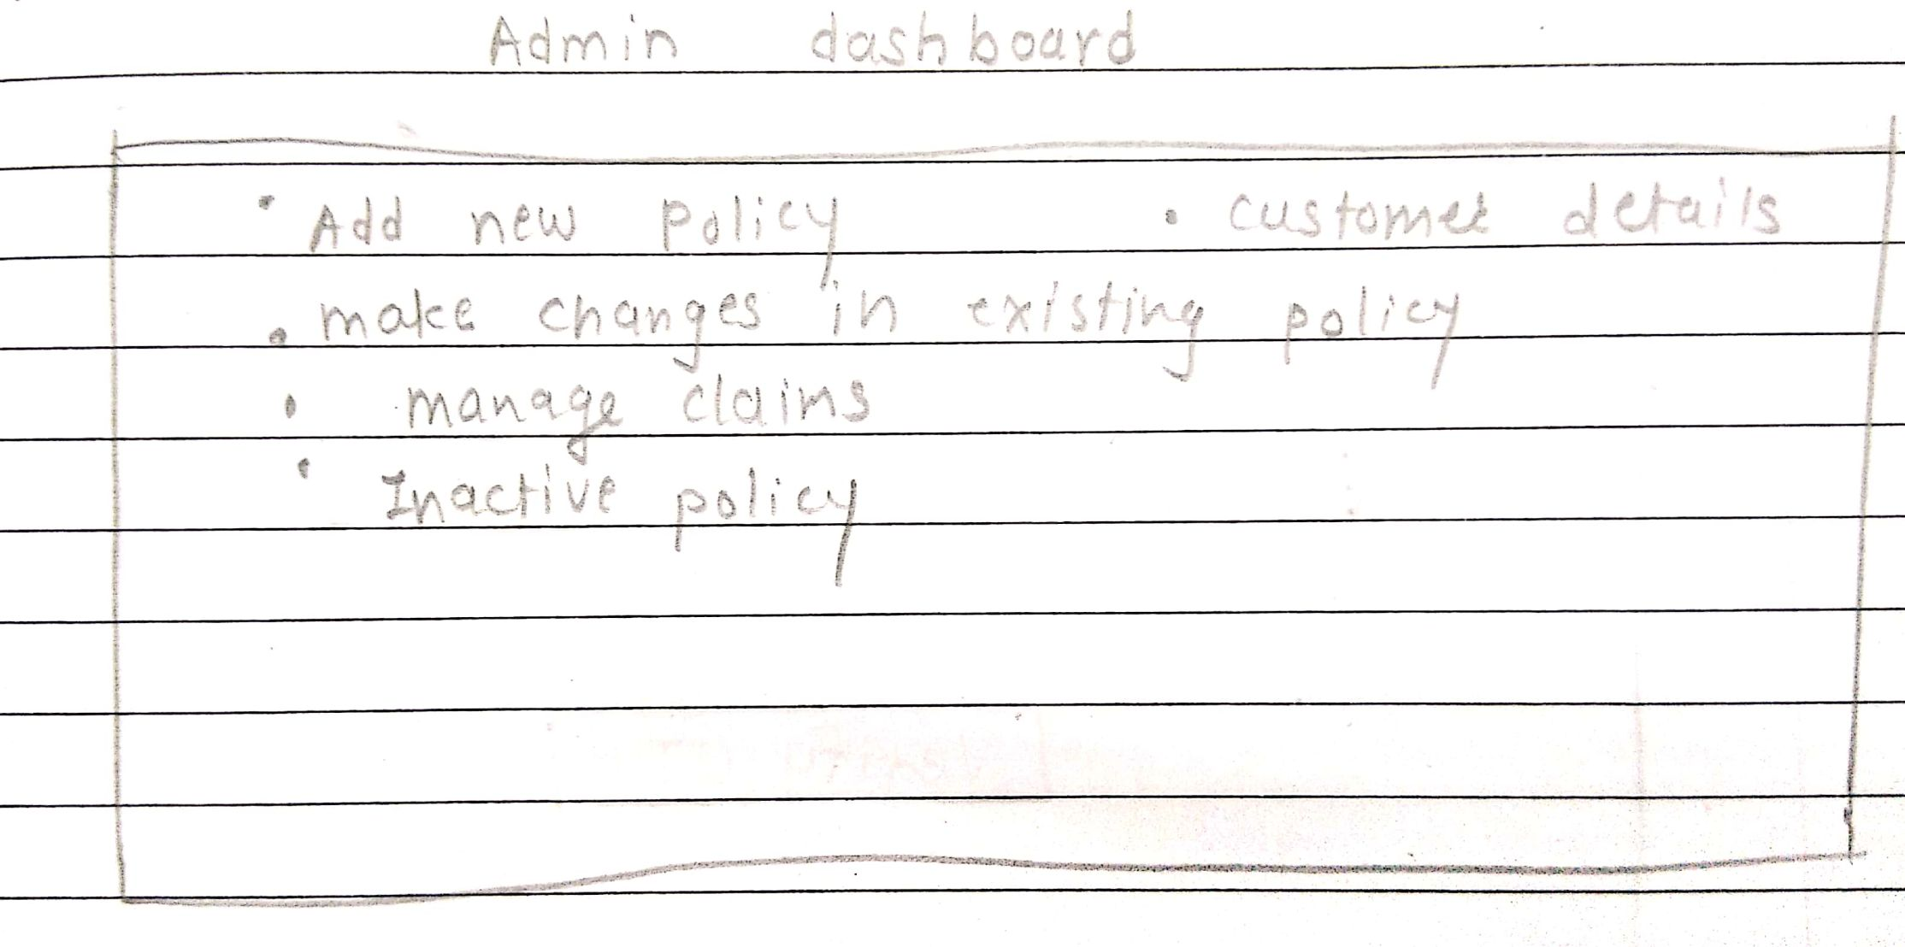

**Admin Login:**

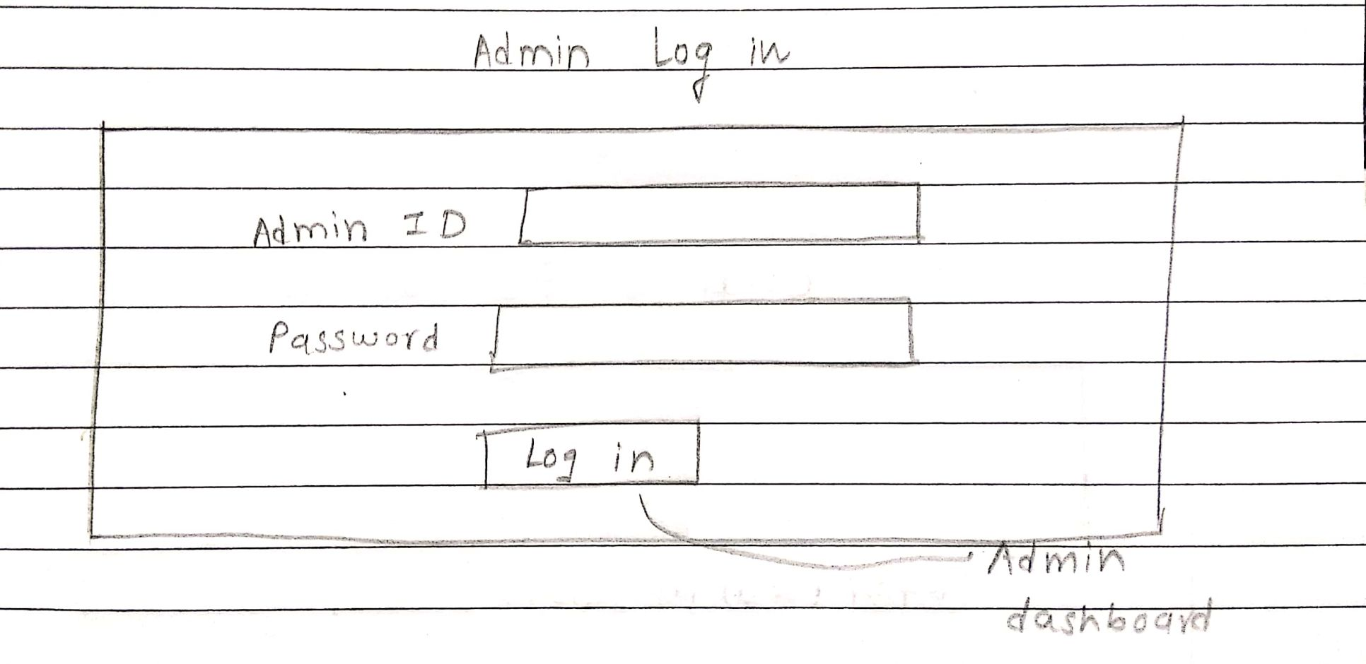

**Forgot Password:**

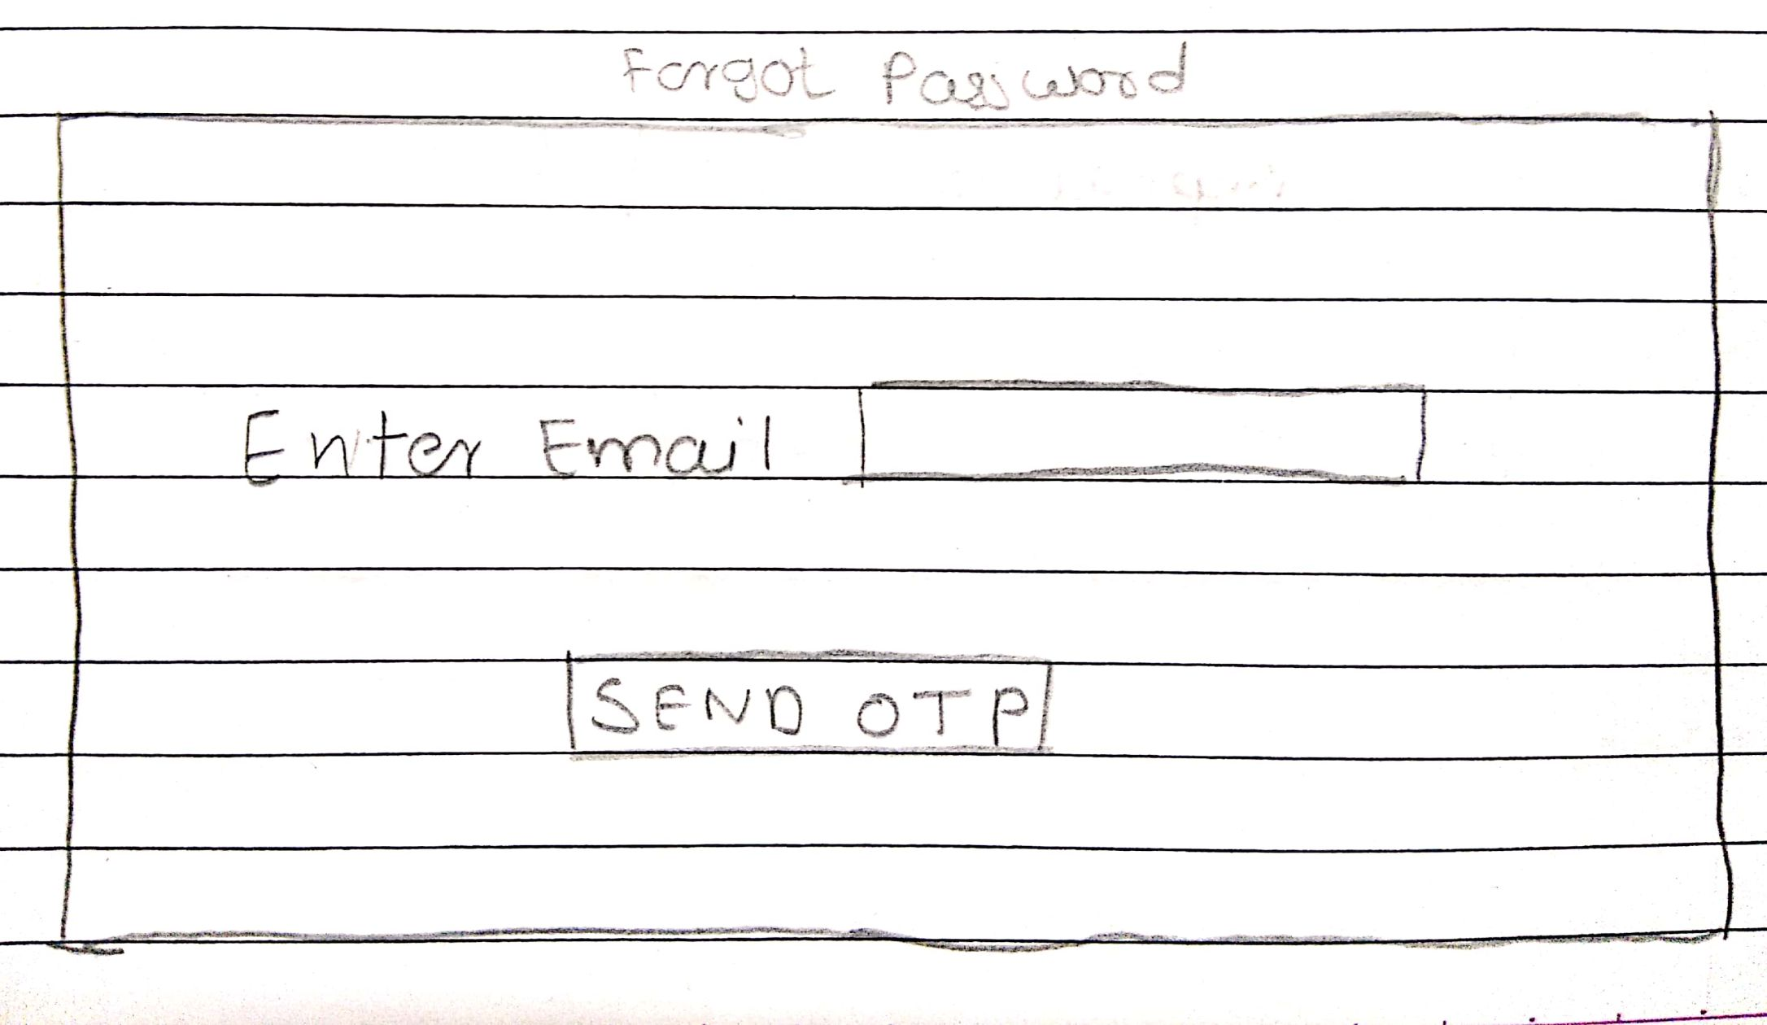**Verify OTP:**

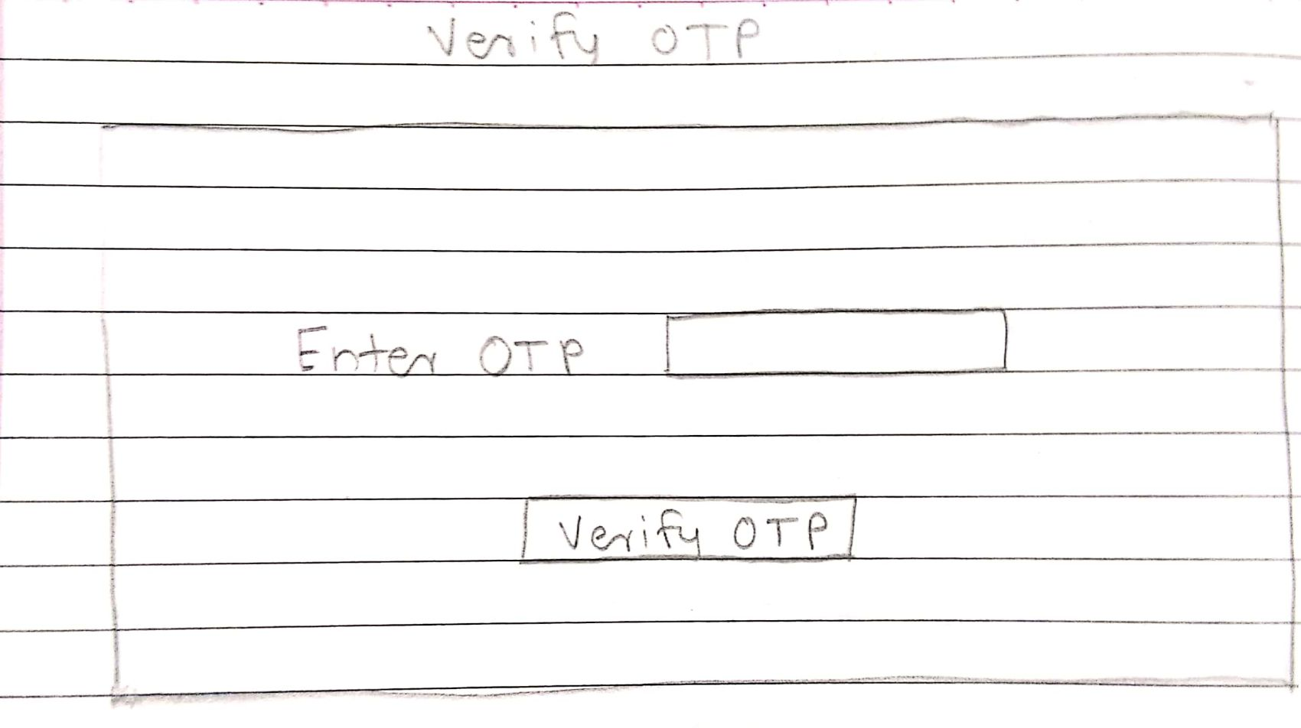

**Change Password:**

